Annual Appropriations for Technology for the Oak Ridge Schools
Source: 2013 CAFR/2013/2014 Budget
2013: $2,779,765
2014: $2,188,101

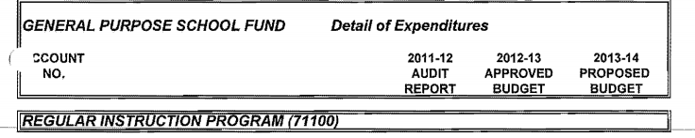

?? 82% reduction in teaching technology from two years ago??
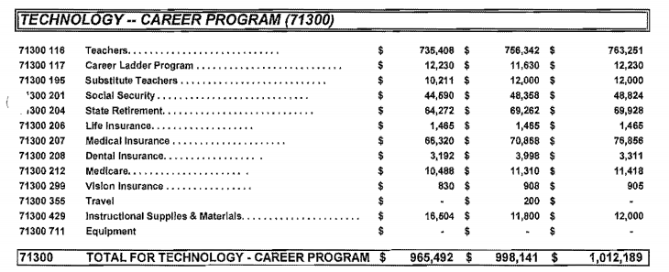
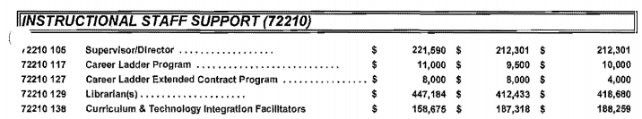
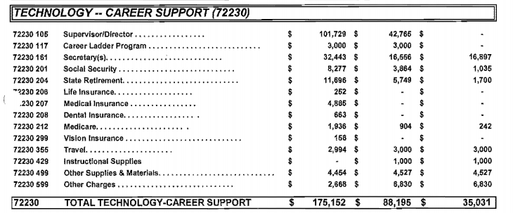
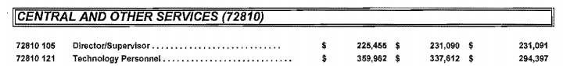
****
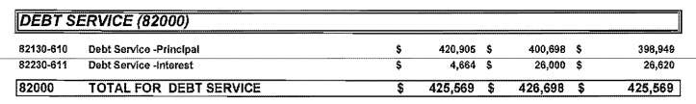

***On August 9, 2011, the Schools entered into a $1,152,844 capitalized lease purchase agreement with California First National Bank for the purchase of approximately 390 computers…. Terms of the lease require initial payment of $301,019 and three annual payments of $301,019 at 2.97% interest
through August 10, 2014.

On July 10, 2012, the Schools entered into a $479,112 capitalized lease purchase agreement with California First National Bank for the purchase of technology equipment…Terms of the lease require initial payment of $124,550 and three annual payments of $124,550 at 2.668% interest
through July 10, 2015.

