Raidsonline.com Police Response Calls to Oak Ridge High School
ORHS YTD (8/12/13-2/13/14) – 26 individual calls
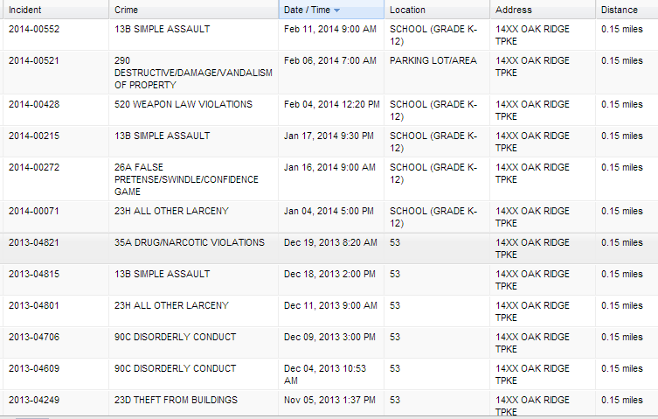
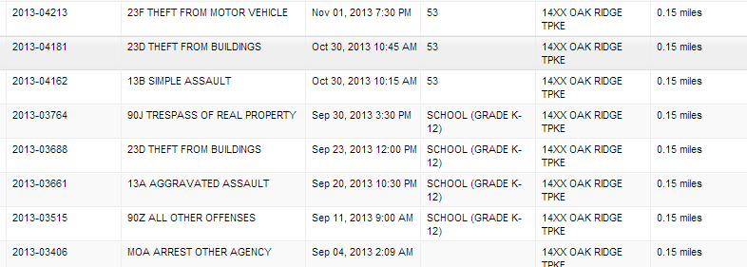
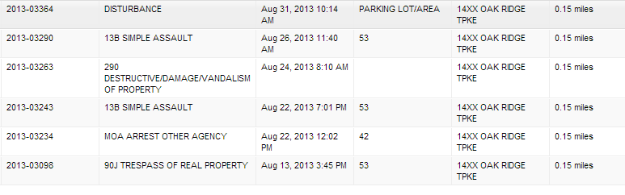

ORHS Last Year (8/13/12-8/10/13) – 57 total calls
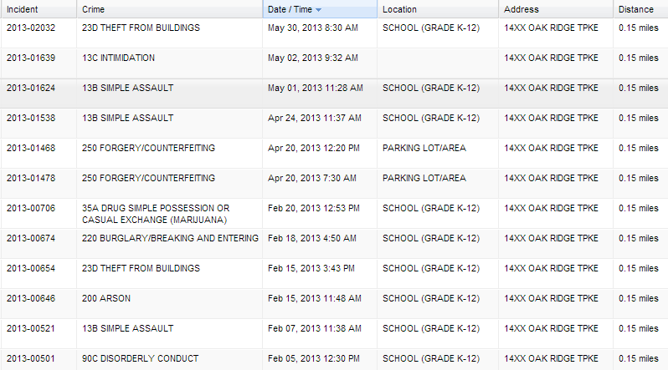
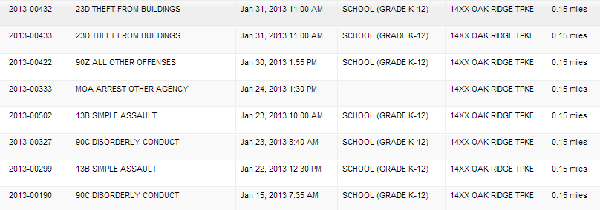
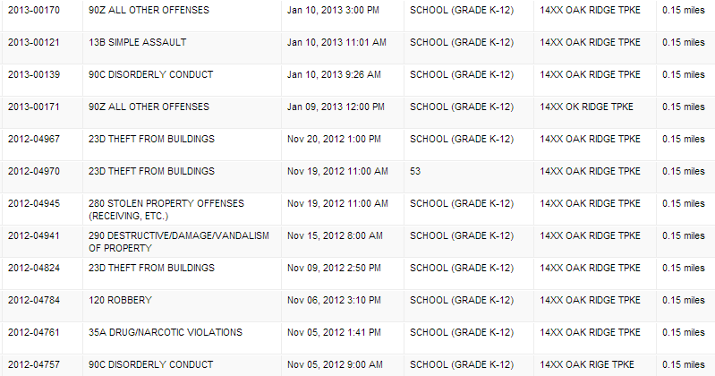
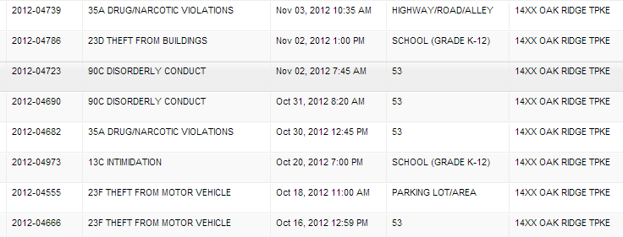
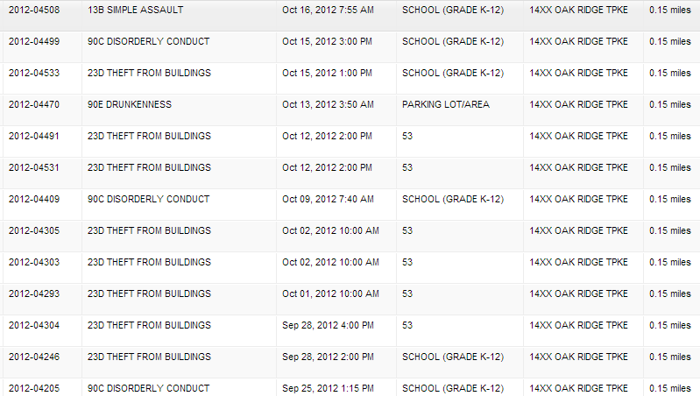
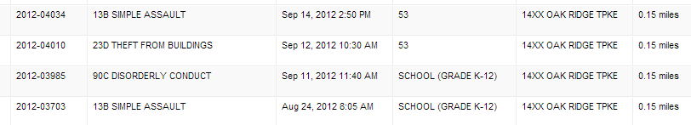

Raidsonline.com Police Response Calls to Oak Ridge Middle Schools YTD

RMS YTD (8/12/13-2/13/14) – 9 total calls

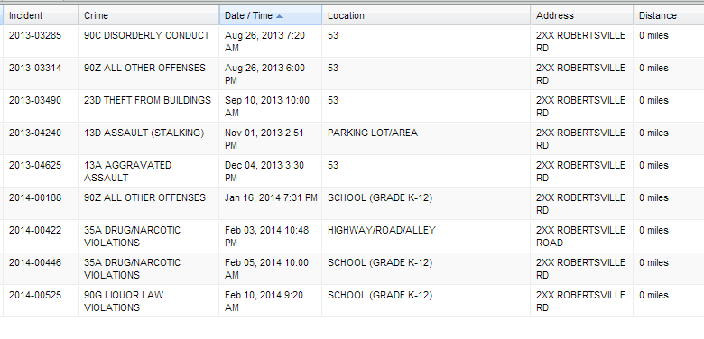
JMS YTD (8/12/13-2/13/14) – 0 total calls
